24 11 105Removing and installing/sealing or replacing transmission oil sump (GA8HP50Z)
Important!
- Do not let skin come in contact with transmission oil and do not inhale fuel vapours.
- Wear protective gloves.
- Ensure adequate ventilation.

Important!
Remove transmission oil sump only after it has cooled down.
After completion of repair work, check transmission oil level.
Use only the approved transmission oil.
Failure to comply with this requirement will result in serious damage to the automatic transmission.
Installation note:
The transmission oil sump must be renewed every time it is removed.

Necessary preliminary tasks:
- Remove rear underbody protection.

Removal:

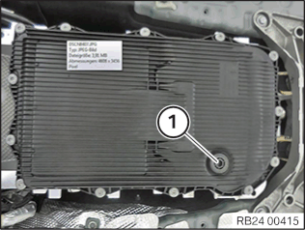 | Remove oil drain plug (1).  Drain automatic transmission oil.

Recycling:
Catch and dispose of escaping transmission oil.
Observe country-specific waste disposal regulations.

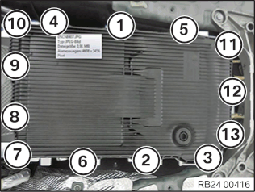 | Unscrew all bolts.  Remove transmission oil sump.

Preparation for installation:
Renew transmission oil sump.
Clean the contact surface of the transmission oil sump on the transmission.

Installation:

Parts: Renew oil filler plug, transmission oil sump and screws.
Clean the contact surface of the transmission oil sump on the transmission.
Insert new screws until screw heads make contact.
Tighten down screws in sequence 1...13 to specified torque and angle of rotation.
Tightening torque 24 11 4AZ.

24 30 101Replacing oil reservoir (GA8HP70Z)
Important!
- Do not let skin come in contact with transmission oil and do not inhale fuel vapours.
- Wear protective gloves.
- Ensure adequate ventilation.

Important!
Valid for vehicles manufactured from 08/2011 onward!
After completion of repair work, check transmission oil level.
Use only the approved transmission oil.
Failure to comply with this requirement will result in serious damage to the automatic transmission!

Important!
When the hydraulic impulse storage is exchanged, the spring can be relaxed in pulses due to a mechanical fault in the hydraulic impulse storage, resulting in a sudden escape of oil.

Necessary preliminary work:
- Remove transmission oil sump.

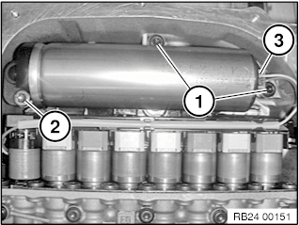 | Release screws (1) (M6x20).  Release screw (2) (M6x59).  Tightening torque 24 30 5AZ.  Carefully unlock connector (3) with screwdriver.  Carefully pull out oil accumulator.  Important!  Mounting bolts of oil accumulator must be replaced after removal.

24 30 Hydraulic / electric control parts and controlling elements

Tightening Torques
 | Type | Thread | Tightening specifications | Torque
1AZ Valve body to transmission | GA6HP19TU / GA6HP26TU | M6 |  | 8 Nm
2AZ Valve housing to valve body | GA6HP19Z / GA6HP26Z / GA6HP32Z | M6 |  | 5 Nm
3AZ Input- and output-speed sensors to mechatronics |  | M6 |  | 12 Nm
4AZ Mechatronics to transmission | GA8HP45Z / GA8HP50Z / GA8HP70Z / GA8HP75Z / GA8HP90Z / GA8P70H | M6x59, M6x20 | Replace screws | 8 Nm
5AZ Oil volume accumulator to transmission | GA8HP45Z / GA8HP50Z / GA8HP70Z / GA8HP75Z | M6x59, M6x20 | Replace screws | 8 Nm
6AZ Centring plate to transmission bell housing | GA8HP45Z / GA8HP50Z / GA8HP70Z / GA8HP75Z / GA8HP90Z | M8X74 | Jointing torque | 10 Nm
 |  |  | Angle of rotation | 90 °
7AZ Speed sensor to transmission | GA8HP50Z / GA8HP75Z | M6X20 | Replace screws
 |  |  | Jointing torque | 4 Nm
 |  |  | Angle of rotation | 12 °

24 34 565Replacing mechatronics (GA8HP70Z)
Special tools required:
- 24 1 430
- 24 2 390

Attention!
- Do not let skin come in contact with transmission oil and do not inhale fuel vapours.
- Wear protective gloves.
- Ensure adequate ventilation.

Note:
After completing repair work:
- Load specific data status with the BMW diagnosis system

Attention!
After completion of repair work, check transmission oil level.
Use only approved gearbox oil.
Failure to comply with this requirement will result in serious damage to the automatic transmission!

Attention!
Read and comply with notes on protection against damage from electrostatic discharge (ESD protection).

Necessary preliminary tasks:
- Remove rear underbody protection.

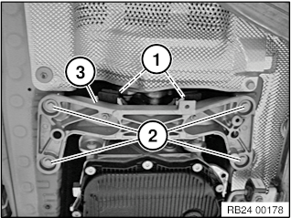 | Support transmission with lifter.  - (Do not use the transmission oil sump as a support. The transmission oil sump must remain accessible.)  Unscrew nuts (1).  Loosen screws (2).  Tightening torque 22 32 3AZ.  Remove transmission cross-member (3).

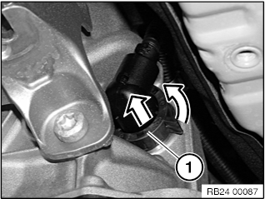 | Attention!  Mechatronics can be destroyed by static discharges. Therefore the contacts inside the connector must not be touched. Insert special tool immediately after operation.  Unscrew connector (1) and disconnect.

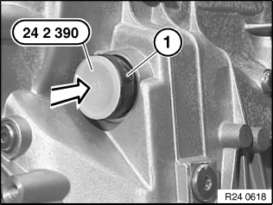 | Insert special tool 24 2 390 in sealing cup (1).

- Remove hydraulic impulse storage.

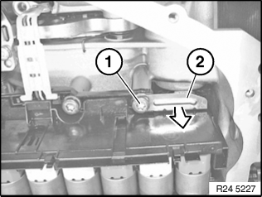 | Release screw (1) and unlock sealing cup with slide (2).  Tightening torque 24 30 4AZ.

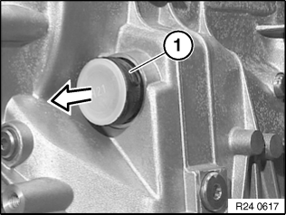 | Note position of sealing cup.  Pull out sealing cup (1).  Installation note:  Replace sealing cup (1).  Fit sealing cup in position (lug on inside). Turn until lug engages in groove of transmission. Slide in sealing cup.  Lug on sealing cup must not be damaged!

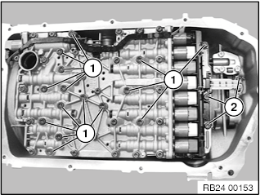 | Release all screws (1 and 2).  - 1 = M6 x 59 mm  - 2 = M6 x 20 mm  Attention!  Pay attention to the mounting orientation of the output speed sensor before removing the mechatronics.  Carefully remove mechatronics.  Installation note:  Replace all screws (1 and 2).  Replace O-rings for oil ducts on the mechatronics unit and wet with automatic transmission fluid.

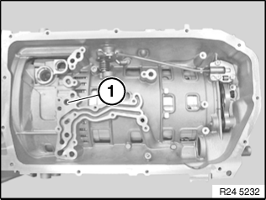 | Installation note:  Replace sealing cup (1).  Coat new seal with automatic transmission fluid and install.

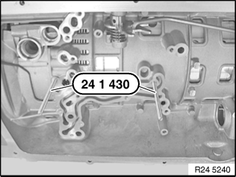 | Screw in guide pins 24 1 430 at screw position 4 and 9.

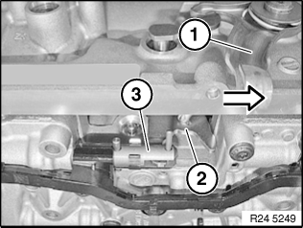 | Fit mechatronics unit.  Fit shift claw (2) in gearshift shaft (3) by pressing release lever (1).

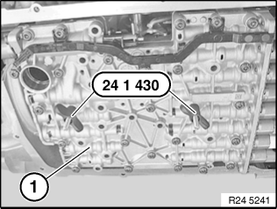 | Screw down wing nuts as far as they will go on to the mechatronics unit.

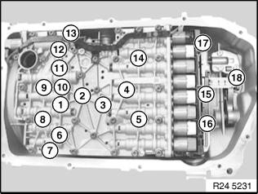 | Observe different screw lengths.  Failure to comply with this requirement will result in serious damage to the automatic transmission!  Installation note:  Insert screws 8 and 14 until screw heads make contact.  Remove the guide pins and screw in screws 1 to 16 and screw 18.  Tighten screws in sequence 1....16.  Tighten screw 18.  Tightening torque 24 30 4AZ.  Note:  Screw 17 is screwed together with the hydraulic impulse storage.  Install the hydraulic impulse storage.
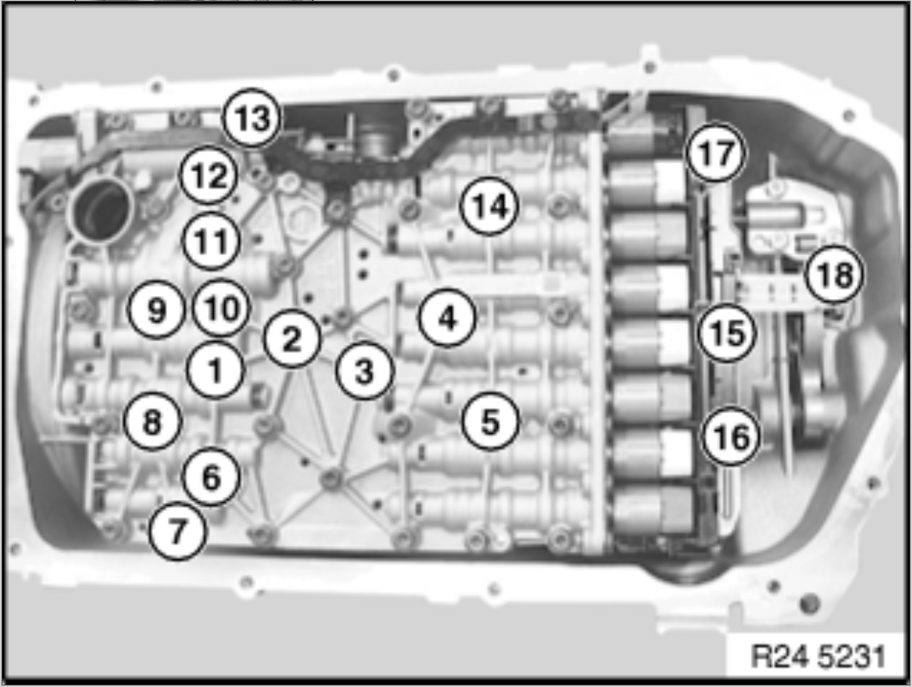

24 30 Hydraulic / electric control parts and controlling elements

Tightening Torques
 | Type | Thread | Tightening specifications | Torque
1AZ Valve body to transmission | GA6HP19TU / GA6HP26TU | M6 |  | 8 Nm
2AZ Valve housing to valve body | GA6HP19Z / GA6HP26Z / GA6HP32Z | M6 |  | 5 Nm
3AZ Input- and output-speed sensors to mechatronics |  | M6 |  | 12 Nm
4AZ Mechatronics to transmission | GA8HP45Z / GA8HP50Z / GA8HP70Z / GA8HP75Z / GA8HP90Z / GA8P70H | M6x59, M6x20 | Replace screws | 8 Nm
5AZ Oil volume accumulator to transmission | GA8HP45Z / GA8HP50Z / GA8HP70Z / GA8HP75Z | M6x59, M6x20 | Replace screws | 8 Nm
6AZ Centring plate to transmission bell housing | GA8HP45Z / GA8HP50Z / GA8HP70Z / GA8HP75Z / GA8HP90Z | M8X74 | Jointing torque | 10 Nm
 |  |  | Angle of rotation | 90 °
7AZ Speed sensor to transmission | GA8HP50Z / GA8HP75Z | M6X20 | Replace screws
 |  |  | Jointing torque | 4 Nm
 |  |  | Angle of rotation | 12 °

24 31 564Replacing torque converter shaft seal (GA8HP70Z)
Special tools required:
- 00 2 300
- 13 5 250
- 24 0 200
- 24 1 420
- 24 2 410
- 24 1 410

Important!
- Do not let skin come in contact with transmission oil and do not inhale fuel vapours.
- Wear protective gloves.
- Ensure adequate ventilation.

Important!
After completion of repair work, check transmission oil level.
Use only approved transmission oil.
Failure to comply with this instruction will result in serious damage to the transmission.

Necessary preliminary tasks:
- Remove torque converter.

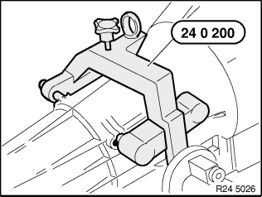 | Secure transmission with special tool 24 0 200 on assembly stand 00 2 300 .Note:  Read and comply with note on installation of transmission retaining bridge.

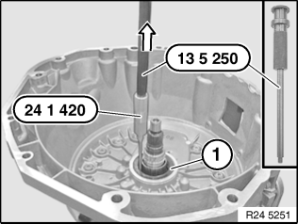 | Pull out radial shaft seal (1) with special tools 24 1 420 and 13 5 250 .

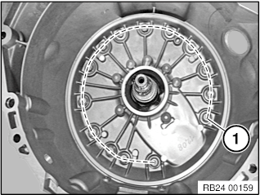 | The 14 aluminium torx screws contained in the drive repair kit are furnished with a sealing ring and must be mandatory replaced as well.  When replacing screws (1) along the dashed line, always change one screw after the other.  Tightening torque 24 30 6AZ.

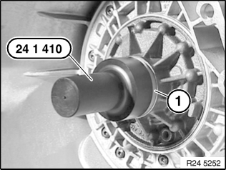 | Installation note:  - Install the O-ring on the drive shaft.  - Oil sealing lip on shaft seal.  - Drive in radial shaft seal (1) with special tool24 1 410 as far as it will go.

